

*ITM 90A/B – Capstone Project*

Ragavi Ravindran - 500640787

Kerin Chrysostom - 500639652

Emil Gnanapragasam - 6474730582

Duke Rupenthiran - 500557210

Anthony Lucchese - 500554477

Submission date: Tuesday March 26th, 2019

Professor: Ana-Maria Herma

Section: 031

Table of Contents

*Exectuvie Report* 3

Acknowledgement 5

Introduction 6

Existing Process Analysis 6

Company Profile 6

Existing Process 7

Performance Assessment 7

Description &Assessment of supporting

Information Technology 8

Process Design 9

Process Design 9

Gap Analysis 11

Key Performance Indicators 12

Change Management 13

IT Solution Supporting Business Process Change: System Requirements 15

Functional Requirements 15

Non-Functional Requirement 17

RFI 17

Feasibility Analysis of Proposed Solutions 17

Vendor Profiles 17

Requirements Assessment 20

Cost/Benefit Analysis 23

Risk Assessment 27

Recommendation 29

Implementation Plan 30

Planning 30

Installation and Conversion 31

Testing 31

Training 33

Documentation 34

Concluding Remarks 34

References 36

Appendix 37

**Executive Report**

Purpose: The purpose of this project is to align the changes with the business goals, in order to construct the uppermost efficiency possible that will improve the current business processes for Cucina di Paisano.

Objective: The project must achieve the following objectives: to analyze and improve any current business processes and provide the steps and tools that may be required to implement these changes. Our main priority is to improve Cucina di Paisano’s technology side to their business, which is planned to improve three different aspects of the business.

Scope:

|  |  |
| --- | --- |
| **Inclusions** | **Exclusions** |
| * Point of Sales (POS) System * Ordering Technology * Telecommunication * Social Networking pages | * Other divisions |

Approach: First, DAREK Consulting and Technology will be looking into implementing a system to help the front and back end of the restaurant to communicate in regards to seated tables. This will help improve time efficiency by cutting some buffer time from the moment a table places an order, to the time their food is received. Secondly, DAREK will be aiming to implement a more social and online friendly interface. The goal of this is to be more accessible by more people, giving customers more methods to receive the food. In order to execute this, the restaurant will be using “WaveSoft” to develop an iOS application that can be used on iPads for customers to be able to order their meals from their seats, instead of waiting for a waiter or waitress to assist them. Finally, DAREK would like to implement a computerized daily cash out system for each waiter and waitress to use. This will allow the new POS system to record all transactions that we made by cash or debit/credit throughout the day, making it easier to count the end of day cash out. The goal of this is to use staff time more efficiently, as cash outs is a task that is undertaken multiple times throughout the day, depending on the number of staff members on the floor.

Key Requirements:

* End of Day cash counting system
* POS transaction system
* Order queue display for customers
* Front-end to back-end staff communication system
* Sales/Transaction tracker
* User friendly tablet ordering system at seated table
* Strong social networking pages
* Strong website to incorporate third party deliverers; Uber Eats, SkipTheDishes

Outcome: Based on the restaurant’s requirements, vendor responses and feasibility analysis, the recommended solution is to reach out to the potential vendor “WaveSoft”. WaveSoft’s system meets all the aspects that the restaurant is seeking to implement in their new system. There are three main concepts to the WaveSoft software possess; iKDS, WavePOS, and WaveTouch. The main reason for suggesting this vendor to Cucina di Paisano is because they heavily support POS systems and mobile applications. Given that the restaurant is aiming to incorporate a higher degree of technology into its everyday functions and interactions, makes WaveSoft a great vendor to reach out to. Along with choosing WaveSoft as a potential vendor, we also suggest that the restaurant invests in a television prompt similar to those of at McDonald’s, to display an order number queue. This queue will both help the front-end and back-end staff to determine which order to fulfill first, and also allows the customer to be notified approximately how long their waiting time will be. With major investments and stronger focus in technology, we will be able to help Cucina di Paisano reach their goals within their new business process.

**Acknowledgement**

The accomplishment and final outcome of this project required a great deal of guidance and support from our client and we are honoured to have gotten the assistance throughout the completion of our capstone project. Everything we have accomplished is only due to the supervision and help we have attained and we would not forget to thank our client.

We thank and respect Mr. Ravindran Kanagasabai for providing us with an opportunity to work with him and his business, Cucina Di Paisano. We sincerely appreciate the time you spent with us and all the effort you have put in to ensure we obtained the necessary information needed, reviewing our work and providing us with meaningful feedback throughout our competition towards the project.

It was a pleasure working with you Mr. Ravindran Kanagasabai, and we have acquired many new things while interacting with you. We all felted motivated and encourage working on this project due to the encouragement you gave us.

**Introduction**

Cucina di Paisano is an Italian restaurant located at York Mills and Don Mills. The purpose of this report is to outline the reason and illustrate how we are going to implements the new ideas. We will begin examining the existing process at Cucina di Paisano and researching the issues related to it. After that, we will begin the process design aspect. We are looking into how we can change the process and create new features. Finally, we will describe the changes made within Cucina di Paisano. The change management will explain in depth on how these changes will affect the current policies and structure of the restaurant. Soon after, we will contact potential vendors who would be able to provide us the tools to execute this project. With further research and inquire, as a team we will provide our client, Cucina di Paisano, with a recommendation we believe is best suited for them.

**I. Existing Process Analysis**

**Company Profile**

Cucina di Paisano is an authentic Italian cuisine whose goal is to bring a little taste of Italy home. The restaurant has been operating since 1965, and still continues to grow in success. As of today, it has been under the control of two individuals. The original owner ran the business for the initial 35 years prior to the existing owner. Cucina di Paisano was originally located near Yonge and Sheppard under the name Paisano’s Italian Garden Cafe, although, due to internal reasons they were forced to relocate and open at 865 York Mills Road, North York, ON. The other location remains open under different management, however, has no relation with Cucina di Paisano. The new location has been open now for a little over 2 years and has been performing just as great as the original location. With the help of our consulting company, we believe this company can grow tremendously and continue to succeed which happens to be evident with the company earning up to $2.9 million in sales last year.

Cucina di Paisano is a larger restaurant in size and decorated perfectly to match the essence of the restaurant. Its square foot is about 5850 and has 98 table within the restaurant along with 23 tables on its patio. The restaurant can hold up to 242 customers at one time. This new location is definitely an ideal spot for business lunches, dinner parties, private functions and many others. It has multiple dining areas, allowing them to host multiple events at one time without disturbance.

Cucina di Paisano emphasizes its entire business by making amazing food for their customers. They also have other aspects including; business-like live performances every Thursday night, and the availability of a few of their pasta sauces and dressings for sale.

Every business has a set of factors which help distinguish them as a company and from competitors. The first factor would be the restaurants environment; in terms of location, setting, and decoration of the restaurant. Cucina di Paisano is located in a plaza that is home to various different types of restaurants. The advantage that Cucina di Paisano in this plaza is that it is the only Italian restaurant, it gives the business the upper hand in attracting individuals deciding where to eat. Given that is located in an area that is heavily populated by Italians, it is given an advantage over the other restaurant chains within the plaza. The interior décor gives a vintage appearance with a modern twist. The authentic appearance gives Cucina di Paisano lead in their décor, adding value to their business. Through research and personal experience, the food is well prepared and served with excellent presentation. On TripAdvisor, Cucina di Paisano is ranked as the best Italian restaurant in the North York area out of 52 other restaurants with a 4 out of 5 rating and 231 reviews.

**Existing Process**

Each business process is handled in a different way and are processed through various staff members. We have overlooked the existing process that we have proposed to improved. We analyzed the business process from the time the customer enters the stores, orders food, and dines in. There are multiple events that take place and various people involved in the process to reach the end result. Another process we looked at was the online process of ordering food. We have assessed all the events in the process of placing an order, as well as how Cucina Di Paisano receives the request from their online website and other platforms. Request are sent to the restaurant where they receive printed slips of the order, they later process the food order. Additionally, we have looked at the cash-out process and examined how Cucina di Paisano informs their waiters to process the cash during the end-of-day procedures. There are numerous events that take place in order to ensure that the cash is balanced. Below we have displayed the existing in-store order process, online ordering process and the end-of-day cash out process. Each of these existing processes shown below we plan to change and improve.

**Performance Assessment**

Throughout our performance assessment, we established three factors that we analyzed that caught our attention. Firstly, the restaurant could really utilize some sort of technological communication that could help ease the communication between the front-line staff and the kitchen. Secondly, the restaurant does not incorporate enough technology into the daily processes such as online ordering or social media advertisements that could bring foot traffic to the restaurant. Finally, the restaurant still uses manual entry mode for all cash deposits made at the end of the day.

The restaurant is currently experiencing delays within the acceptance of an order and the delivery of food due to the lack of efficiency between the front-line staff and the kitchen as well because of poor technological communication placement. During the peak times of the restaurant, it is important for the kitchen staff to have the proper order information in order to serve each customer without any issues. However, having improper order information can be apparent when the restaurant is busy and the server does not have enough time to display the information the standard way. Currently, the standard way of taking down order is done by the servers, where they take down the order on a paper and later input it into the system. The time duration of this process is slow compared to many other operations that utilize technological communication. Valuable time is loss during this process as the current wait time during prime time for food could turn out to be as late as 30 minutes during peak hours. Although no industry benchmark exists within the restaurant, it is important that food orders are made within a specific timeframe and not late. During peak hour, it takes approximately 30 minutes to prepare the food ordered by customers which can be decreased if a proper technology communication is placed to smoothen out the daily process of food orders

The restaurant currently utilizes minimal social media advertisements and online orders during the day-to-day process. It is important to help scale this part of the operation as the current process after an assessment of performance lacks efficiency and is outdated. Technology is an integral part of any restaurant in helping to build the business and right now, the technology must improve to adapt to the changes around the world that is taking place in the industry. Although they currently utilize third party delivery system such as UberEats, they must try to expand and integrate more delivery systems and make the company known through social media as it could bring foot traffic into the restaurant. Doing so, will help the restaurant grow as it will be popular through the various platforms of social media.

Cucina di Paisano currently has a manual entry method for all cash deposits made at the end of a shift/day. This process is tedious and very time consuming as it requires each waiter/waitress to go through all the receipts and add up the totals, while filling out a cash slip. This cash slip is then passed over to the manager who will then enter the numbers from the cash slip onto an excel file in the database. The whole process is very time consuming and has a large room for error. This is due to the fact that it requires servers to manually subtract tip totals and sales totals separately at the end of each shift. This process could definitely be improved by automating the process, or having the transactions run through an external database where it does all the calculations for the sales.

**Description and Assessment of supporting Information Technology**

Cucina di Paisano is currently using minimal technology to assist with day to day functions at the restaurant. Some of these functions include taking orders, assigning tables, waiters, and the total amount of cash made. Although the restaurant has many daily tasks to be completed, the restaurant only utilizes a tablet, printer, and Microsoft Excel to assist with these functions. After visiting the restaurant, we noticed that the restaurant does not have an actual local system or program that they can use to organize all the daily sales information. Microsoft Excel is used to keep track of the daily cash flow, and the amount of cash generated by each waiter of that working day. In order to attract customers and increase in store sales, the restaurant has its own social media page on Instagram and Facebook. Paisano’s finds itself at a disadvantage because of the lack of technology used to assist the employees and manager run the restaurant.

**Description of current use of technology at the restaurant:**

**1. Printer**

* Prints a small slip that displays table number, the order, and time the order was made
* Receipts/slips are then used to input end of day sales numbers

**2. Tablets**

* Online orders are transmitted to the tablets
* Communicates the order made, customers name, pickup/delivery option, and payment method (in store or online via Visa)

**3. Social Media**

* Instagram page portrays images of all the dishes on the menu and daily specials served at the restaurant
* Facebook page offers information on the different locations, store hours, holiday specials, and menu

**4. Excel Spreadsheet**

* Identifies waiter name, debit machine 1, debit machine 2, debit machine 3, cash, and total of all cash
* Organizes daily cash flow, but numbers are manually inputted based off receipts from printer
* Daily numbers not available on any other system

**Figure 1.1**: Spreadsheet for End of Day Numbers 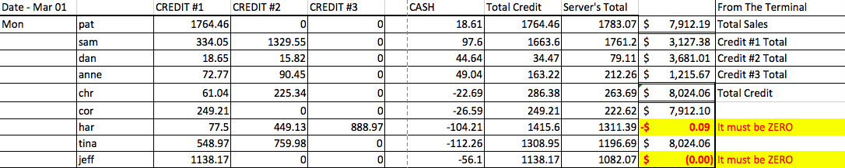

**II. Process Design**

**Process Design**

The process that employees are currently dealing with at Paisano’s is old and outdated and it’s been our job to implement three different processes that would be much easier for employees to use and also aid the experience of the customers. During the current and ongoing process, the customers do not have any indication of the arrival of their meal. We originally came up with the process of an indicator that gives the customer an update on their table and meal and we’ve now established an electronic device that would signal when this is ready. Another process that we’ve expanded on was for the kitchen and front-line staff, specifically in terms of food preparation and making sure everything is prepared in a timely manner. We’ve now established utilizing a large monitor that would display all the information for the kitchen staff to prepare the meals more efficiently, with things such as time since the meal has been ordered and exact order details. This will improve efficiency in the kitchen as mentioned and will also increase customer satisfaction.

Our next process was the expansion of utilizing social media to introduce new customers to the restaurant. This is an always growing tool that could drive the restaurant to the next level by reaching a younger audience and showcasing the food that they have to offer. We’ve now established using a variety of applications to aid thig such as Instagram and Twitter, with direct advertising links that would lead to our online ordering system or restaurant address for in-person dining. We have also decided to continue pushing the food delivery platforms such as UberEats and Skip the Dishes.

Our final process was very important because it involves making the daily process of food total and calculating tips more efficient. Paisano’s currently uses an outdated process and we’ve now fully established a plan to automate this process and run more smoothly on a daily basis. A system would input these numbers directly into the computer, where all different kinds of totals are calculated, time is saved and errors within the process are eliminated. The system would print out a receipt at the end of the day with the cash totals along with an overnight receipt, going directly to the manager and deposited at the bank.

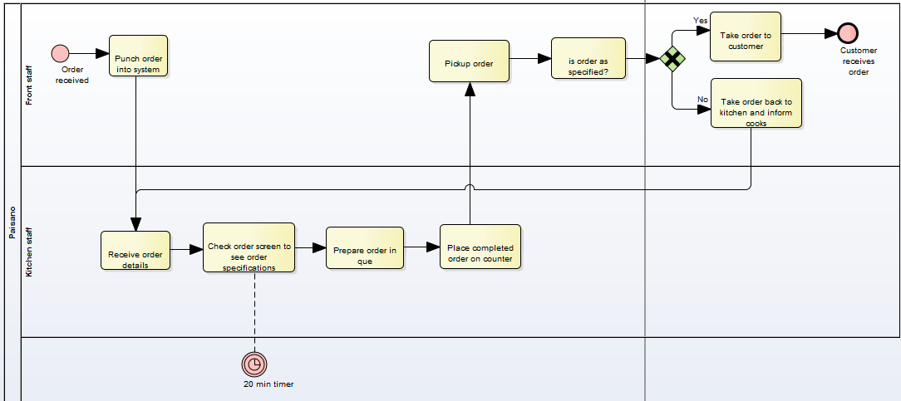

**Figure 1.2**: Current process of customer ordering food.

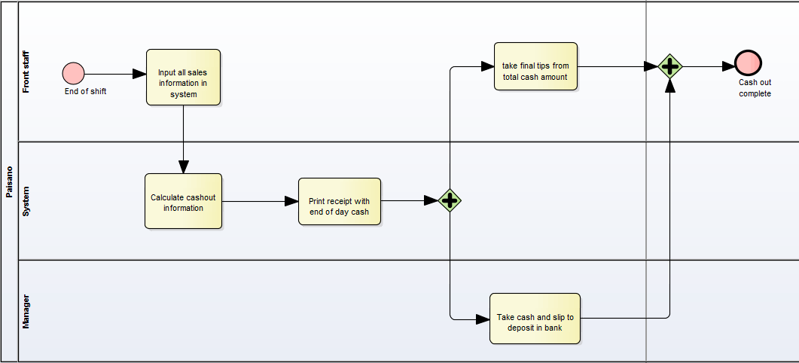

**Figure 1.3**: Current process of waiter/waitress cash process.

**Gap Analysis**

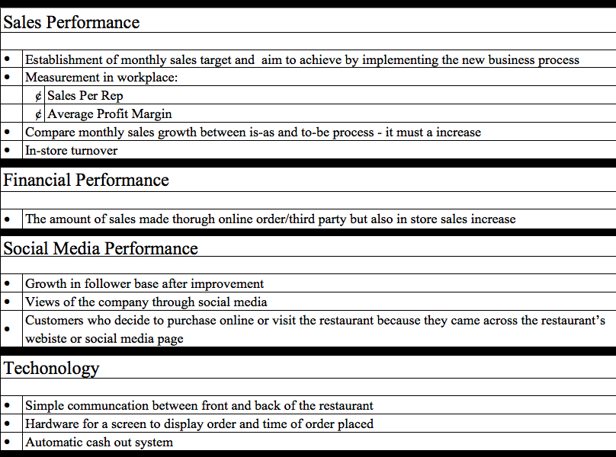

**Key Performance Indicators**

To evaluate the new business process, we will be using various Marketing, Sales, Financial, and Social Media performance indicators. Our new business process aims to assist in implementing a new method to perform financial transactions and end-of-day count procedures along with methods to increase online sales and social media attention; hence, the reason why we chose to focus on the specific metrics noted above. In order to evaluate the efficiency and effectiveness of the new business process, the following performance indicators will be utilized:

**Marketing Performance Indicators:**

* Brand awareness – The extent to which consumers are familiar with the restaurant Paisano’s and the food available on the menu
* Customer acquisition cost – The cost spent on acquiring more customers divided by the number of customers that were acquired during the time the money was spent

**Sales Performance Indicators:**

* Sales target – Establish a new monthly sales target with the implementation of the new business process
* Sales per rep – Calculate the daily sales per waiter
* Average profit margin – Net profit divided by sales
* Monthly sales growth – Compare the growth in sales before and after the new process has been implemented

**Financial Performance Indicators:**

* Net cash flow – The difference between the restaurant's cash inflow and outflow
* Gross profit margin – The difference between the revenue and cost of goods sold divided by the revenue

**Social Media Performance Indicators:**

* Followers growth – The increase in followers before and after the new process (Instagram and Facebook)
* Social visitor goals – The number of visits made to the restaurant’s social media pages (Instagram and Facebook)
* Social shares – The number of posts under the restaurant’s accounts that are reposted and shared by other social media followers and/or users
* Traffic conversions – The number of customers that decided to purchase online or visit the restaurant because they came across the restaurant’s social media page(s)

**Change Management**

Change management is defined as a systematic methodology that deals with the transition or revolution of a company’s objective, processes or information technologies. The objective of change management is to control the lifecycle of all alterations through implementing tactics and allowing valuable modifications to be completed with minimum disruption to the company. This aspect of management focuses on responding to consumers’ demand while maximizing market offering and responding to business and IT requests; making changes and aligning it with the organization goals. It is crucial for organizations to successfully analyze and understand the how existing process, systems and employees within the organization will be impacted through the adjustments and replacements that will occur.

Currently, Cucina di Paisano’s current processes are handled in various strategies. For example, communication between the server and the back kitchen is handled in such a way that the server inputs customers’ orders into a system. Once they are placed, the order slip is printed, and the chef prepares the meal and ensures the order is accurate based on the slip. Paisano’s allows customers to place orders in stores as well as on their website. Another process deals with the front-line staff and management. This process requires staff members such as servers to calculate their end-of-day sales and total tips.

Our company, Darek’s Technology and Consulting is implementing a new process that will change Cucina di Paisano existing procedures. We are implementing three different technologies that will improve the process. First, one of the information technologies we are trying to enhance is the communication between the front and back of the restaurant by implementing a screen that displays the order time, the food order and the respective table number. Second, we are employing social media to increase advertisement and attract more online orders. Third, we are executing a system that allows us to input numbers into the system that will calculate cash flow automatically.

Integrating new systems within the company can bring success and improve the existing process or negatively impact the company, as this will change how the business operates and affect members of the organization in some way. Using the Leavitt diamond model, it will illustrate how change is managed through the organization through a structure of four different entities known as people, structure, task and technology.

At Cucina di Paisano, they have employees who help operate the workplace where they utilize their skills, efficiency and knowledge. The new cash-out system that allows servers to input numbers into a system that then calculates the cash flow automatically alters the way servers calculate cash flow. The previous cash-out process requires more work as it would have been done manually. Changes in task would impact employees as they would have to be first introduced to the new method and trained on how to utilize the new system.

The structure of Cucina di Paisano would be altered as members of the organization such as management as well as employees must adjust to the implementation of the new system. Aspects of this new system such as that which aids in the communication from frontline to the back will reduce wait times and the way the two departments communicate with one another. This change the structure of the business because they will have limited number of employees compared to before.

Changes in the business process can make members of the organization feel uncomfortable and can take a long time for employees to adjust. They way employees perform their task can alter as time progresses. Modifications made within Cucina di Paisano will alter how things are being done and the company’s goals. Any variation that occur in the business is done to achieve an ultimate goal that a company has set. Our goal is to provide Cucina di Paisano with valuable system that will enhance their business process to better assist customers. Advancing the existing process to adapt to technology will alter the way the business operates and will raise the benefit of the goals. Implementing systems will make the tasks more productive where the company will be able to work at their full capacity. The systems we are executing in Cucina di Paisano will increase customer orders, attract new customers through the use of social media and improve their process of financial activity between managers and servers.

Technology has evolved through time and is a major advancement that companies are implementing to aid in the operation of their business. It is a component that supports and facilitates individuals to perform their task. At Cucina di Paisano, technology is a key component we will be deploying to their process as it will help perform multiple tasks. We will be utilizing an excel application to input day-to-day numbers to determine the end of the day net cash and another system to display order numbers, order information and time lapse of 20 minutes to prepare the order. Lastly, we will be creating a social media platform to attract more online orders.

It is important to manage and monitor changes that occur in the company. Documentation will help the company analyze how such transformation to the current process benefits the company. Companies can alter their operation but as key stakeholders of the business, they must ensure that the change is benefiting them. We have analyzed how revolution will affect four different entities and how each will need to adapt to the transformation continuously. Change is evolutionary, and it is important for companies to promote change to improve their business.

**III. IT Solution Supporting Business Process Change: System Requirements**

**Functional Requirements**

**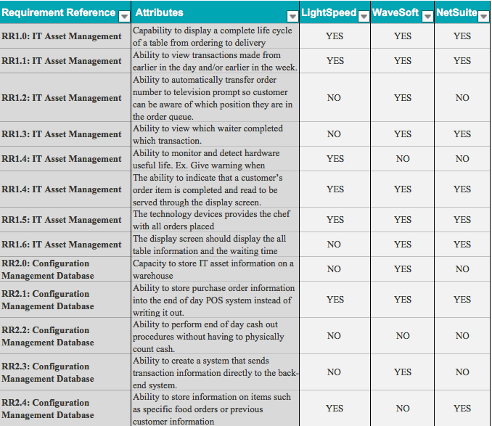****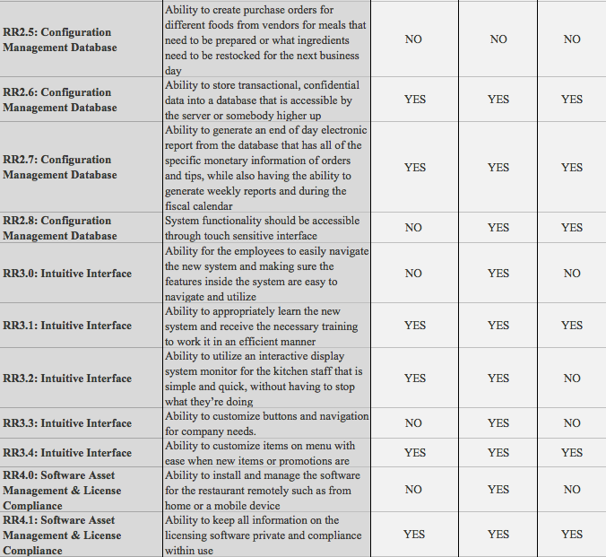**

**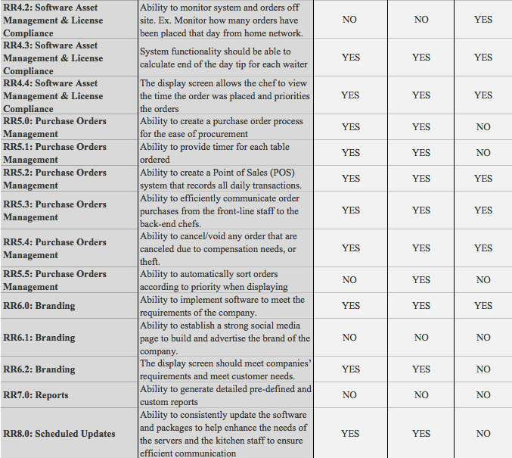****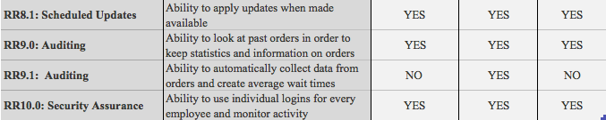**

**Non-Functional Requirement**

In this section of the RFI we will be discussing the non-functional requirements that Cucina di Paisano will require in order to move forward with a specific vendor. This will include everything from hardware, capacity, operating system and usability. We want to ensure that the system is able to operate efficiently and effectively with no issues. One of the main features we require from our system is for it to have the ability to monitor the time of each orders along with the capability to record the delayed orders in the system for future statistical reports. This will allow for Cucina di Paisano to see statistically which orders usually take the longest and which ones do not, in order to operate smoothly in the future. Along with this we will also require that the vendor has the capacity to display all orders that are placed throughout the restaurant. This includes anything from dine-in, take-out, and online orders. In order for the system to be able to record all this, there are certain devices that will be required with certain capabilities. Next, we also require the system to have the abilities to update via Wi-Fi. This is essential as it will reduce the future costs of having technicians to come in to update system software. Finally, the system is going to be used by all individuals in the restaurant and should be able to log the inputs that are placed in the system and when they were inputted. Once we have acknowledged that a vendor can provide all of the above, we will be able to move forward with a specific vendor.

**RFI**

*See Appendix B for more information*

**IV Feasibility Analysis of Proposed Solutions**

**Vendor Profiles**

We will use this next section to give a brief background of the proposed solutions in terms of the vendor process. To begin with, we have examined a complete and detailed background for each vendor. For Lightspeed, they are led by Dax DaSilva and provide us with many different restaurant features to choose from keeping track of food stock to a fully customizable menu with all different meals. The key features that Lightspeed would provide for us would be the Kitchen Display System and POS system, which would manage the entire restaurant in one application. For WaveSoft, they offer us plenty of experience within the industry and also offers dependability. They will offer us a POS system that is guaranteed to create a smooth daily process for the employees and a fully serviced iOS application, which was the first of its kind. For NetSuite, they will offer us a cloud-based multi-channel retail management solution that gives us real-time insights and analytics in terms of the customer behavior, sales, inventory and finances of the client. NetSuite also offers us the ability to modify and add new capabilities to the system and could really provide plenty of value for the growth of our client by utilizing the cloud system they would offer us**.**

**Lightspeed**

Lightspeed is a vendor that empowers both retail and restaurant business. Lightspeed’s focus goes beyond transactions, they’re concentration is to assist entrepreneurs to work smarter, create data-driven decision and design the best experience for their customers. Lightspeed is infused with culture, their values are what keeps them united and their difference is what motivated them. Lightspeed currently have eight different office locations around the world and over 650 employees. The CEO of Lightspeed is Dax DaSilva and the president is JP Chauvet.

Lightspeed has many different restaurants features that will help manage their day to day activities. Lightspeed allows companies to manage their stock which shows them what the restaurant has and what they may need. They provide customizable menu, allowing them to add and remove items, as well as pictures and descriptions. Additionally, they offer a kitchen display that helps the chefs deliver the goods in less time with the display screen. Other features available is iPad POS that stores all the restaurant data, stores the menu and has an ordering system that allows waitress to place orders. Lightspeed cloud-based iPad POS makes it convenient for the business to access information anywhere. The cloud-based POS system allows the business to keep updated with their sales, make emergency changes and store data.

The main product that we want to discuss is the Kitchen Display System. This improves the communication amongst the entire staff to a greater level and ensures that everything is managed in an effective manner. It’s an extremely user-friendly interface, along with superior technical and customer support that puts everything the restaurant needs in one place and makes it easier for them to succeed. The KDS is the new and improved way to manage the kitchen and it says goodbye to the traditional ways such as printing orders with bulky machines or the annoying clutter of tickets scattered around the kitchen. The main features of the system are the displaying of kitchen times in an easy to understand manner and color-coded orders to help the staff know what is being cooked and what is ready to be served to the customer. It sorts the process in three different stages and colors, from the Grey stage/New Order to the Orange stage/Cooking and finally, the Green stage/Done screen and this also displays all the ingredients that are needed to fulfill the order and the estimated finishing time directly from the chef.

Another important product that Lightspeed offers to clients is the state-of-the-art, POS system that managed the entire restaurant in one, simple to use application. Whether it’s customizing the floor plan, customizing the menu or managing the staff and payments, everything is under one application that helps the employees stay efficient. It also helps other processes such as managing takeout/delivery orders, splitting bills and manages the tips for the servers and the customers. Finally, it offers end of day or month reports directly to your mobile phone or desktop computer, with everything tracked such as revenue and staff performance.

**WaveSoft**

WaveSoft is one of the three vendors we chose to analysis the benefits from. Among this industry, WaveSoft is known as a pioneer for the field of mobile point-of-sale industry. They were the first to develop the world’s first Windows CE based POS in 1999. Their mobile software application enables users to perform wireless order entry, payment and line-busting applications and integrates seamlessly with virtually any third-party point of sale software application. WaveSoft is mobile point of sale (POS) creator, focusing in solutions for restaurants within the hospitality industry. They provide the necessary tools in order for your business to grow and continue to achieve and maintain success. WaveSoft produces numerous mobile point of sale technology for your restaurant in a creative manner to reach your requirements. The company alone has gained over 20 years of experience working frequently with businesses, giving the ability to learn and understand the fast-paced dynamic of this type of restaurant. WaveSoft continuously progresses and updates their systems in order to be parallel with the owner’s needs. As of now, WaveSoft operates all their devices on apple’s iOS platform, and is the first company to offer built-in iOS applications for the restaurant. WaveSoft is providing businesses a way to demonstrate excellent customer service by having identical programs throughout the restaurant for employees to become familiar with. It is also important to realize that WaveSoft is not a company that only focuses on large corporations, they also drive their attention towards small bars and mom and pop restaurants.

WaveSoft main motive is to guarantee technology that will help create a smooth, dependable and scalable system operations for businesses. For this vision, WaveSoft has three ranges of iOS solutions: WavePOS, WaveTouch and iKDS. WavePOS is an application they designed to transform the restaurant’s point of sale system into a mobile POS solution. Its main focus is to mimic the existing workflow and interface of the business, in order to produce solution through a tablet, iPad or iPhone. WaveTouch is an application which can be downloaded by the business, to either be used as a tool for servers or as a self-service solution for customers. Finally, we have iKDS (Kitchen Display System) as an application developed to solve the back-house restaurant needs by displaying incoming orders. This will aid the restaurant by implementing a KDS because it will completely elimination paper tickets, saving not only your wallet but the environment as well.

**NetSuite**

NetSuite for retail is a cloud-based multi-channel retail management solution for retailers that combines e-commerce, POS, and order management functionalities. The software provides a unified retail system with back office management to sell products on multiple channels across multiple regions and countries. The application understands the complexities of a retail model, the software and hardware requirements, and allows retailers to focus on customers.

NetSuite for retail enables sellers to configure the application as per their needs. Retailers can add new channels, geographies, business models, and brands. The software provides real-time insights into customer behavior, sales, inventory, and financials. The order management system allows retailers to run "buy anywhere", "fulfill anywhere", and "return anywhere" functionality. The software has an activity dashboard that provides weekly or monthly sales reports for store managers, inventory managers, e-commerce managers, and executives. The software has an ability to modify and add new capabilities into the system as the retailer business grows and expands into new segments.

One of the systems that we are aiming to implement for Cucina di Paisano’s is a back-office Point of Sales (POS) system to assist in recording sales and cash received. The POS system should be able to retrieve all financial transactions made from the front till and/or debit terminals, also should be able to identify the waiter/waitress that initiated the transaction. NetSuite will help the manager of Cucina di Paisano to build a monthly report to establish the top performers of each quarter. Setting quarterly goals and being able to identify which waiter/waitress is underperforming or over performing through activity reports. The activity reports will assist the manager in being able to look back at previous transactions if necessary. The report will also help in keeping all transactions organized per day for the month. Instead of physically writing everything based off receipts, all transactions can now be tracked through the POS system.

NetSuite will make it easier for closers be able to count the end-of-day cash out using the POS system instead of having to do calculations by hand or by excel. The POS system is recording all transactions and cash received for the day, which in return at the end of the day will advise the closer the amount of cash that needs to be deposited to the bank. Using the POS system, the closer will be provided an interface that separates the cash by coin and by bill for example; the amount of nickels taken out of deposit or $5 bills. This makes it easier to calculate and determine if there are any mistakes such as an over or under count. NetSuite helps Paisano’s to effectively and efficiently keep track of all the daily transactions to help the restaurant continue to operate successfully.

**Requirements Assessment**

We will use this next section to give a brief background of the requirements assessment in terms of the vendor process. We will follow that with a complete and detailed background on the company for each vendor. For Lightspeed, they offer us a POS system that keeps the client in control and improves communication between the front-line and kitchen staff with the kitchen display system. Lightspeed is also very reasonable in price compared to the other vendors and is fully customizable to fit the needs of the client, but only offers us services on iPad and not Android. For WaveSoft, they already service high-end clients such as Pizza Hut and McDonald’s. They carry plenty of experience and offers a clear display of the orders and the time, in a simple and effective manner for people to understand. The downside which will be discussed is the lack of information we found on reviews of the service and what hardware would be required for the system to be implemented for our client. For NetSuite, they offer us a capable service that will integrate all of our information into one system and will limit potential discrepancies for down the road. The downside was the reviews of the helpline service online for NetSuite, as communication between our client and vendor will be vital if our client ever runs into technical trouble by using the service.

**Lightspeed**

Lightspeed point of sales system enable the company to perform the core day to day transaction. It is classified as the fastest, most reliable POS system in the industry. It enables you to create your own menu, take orders, update the floor plan all. No matter how crazy the days gets, the POS will enable the restaurant to keep the business in control and help the business run efficiently. The kitchen display system makes sure the customers get what they ordered on time. With the kitchen Display system, it helps enhance better communication as the KDS displays the ticket times to keep track of turnaround. The system uses colour codes that are used for orders to help staff members see what’s cooking and what is ready to go. Moreover, through the KDS it helps manage incoming orders more effectively. Finally, it’s an extremely economically beneficial system because of the low price in cost and implementation of the service, without any hidden set-up or monthly fees. Lightspeed will offer us the ability to track all of the data that comes out of the restaurant through their system and also the ability to receive live and customizable data reports throughout the day that gives the staff and owner an overview of the sales, kitchen reports and also tips. Lightspeed is customized exactly to tailor the needs of a busy restaurant and is fulfills user specific requirements such as being tailored to the kitchen and front-line staff. They also offer state of the art equipment that offers efficient performance and the information technology infrastructure that acts as one unit making this an efficient process. Finally, Lightspeed offers great customer support done through instant message communication on its website and is always available when an issue should arise. The staff that use Lightspeed will have a fully functional and working system that is easy to operate and utilize compared to previous tools used in the restaurant. The POS system that the staff will use could also be used offline without using the local network, so the owner could access his system and data while not at the restaurant, without any service interruption and also with a fully backed up system.

The system only works on iPads and it would be more useful if the system is able to operate through android devices as well. The technology may not perform as well as it was intended to do once it would be implemented, as a chance for a malfunction or glitch always exists with technology. Some of the users of the new system may lack experience using technology in a restaurant setting and although they would receive training, some staff may struggle with learning to quickly adapt to a newer system and how to handle all the different functions it offers if they don’t possess technical expertise**.**

**WaveSoft**

Looking at multiple, there were a number of reason why WaveSoft stood out to us. WaveSoft is a mobile point of sale (POS) creator focusing in solutions for restaurants within the hospitality industry. An aspect which drew us towards them was a feature on their website displaying quiet interesting information. On their website, it displays current client who are still in business with them and many of them were worldwide known companies. A few of them are: McDonald’s, Pizza Hut, Hard Rock, Disneyworld and KFC. They are one of the leading branding in this industry and are experts in what they do. It was very crucial when looking into vendors to consider all aspects which the company shines in but most importantly, what they may lack as a company.

WaveSoft provides the service for business in upgrade their business with a touch of technology. With having a centralized communication method within a large restaurant, it allows the client to possibility improve the performance which will relate to an increase in sales. The two main services which attracted us to WaveSoft was iKDS and WavePOS. iKDS was our ideal solution for the main issue we were attempting to tackle. It provides a clear display of the orders, time, table number and any specific altercations needed the customers. This allowed the employees to communicate with the back kitchen in regards to how long the customer has been waiting. This was a huge plus point for our team because it was clear, simple and exactly what we desired to achieve. Paisano’s size had a huge impact on this decision and stood out as an advantage to us. WavePOS is a service provided which a primary focus to mimic the existing workflow and interface of the business, in order to produce solution through a tablet, iPad or iPhone. This is give the restaurant the ability to still have their current system however, improve the method currently used. It allows us to integrate the process into our existing technique without interrupting our workflow. Both services were functional for our project and believe it would be smart to attempt and contact this vendor. The overall outlook on WaveSoft as a vendor was respectable and corresponded to our expectations. The cost of the service was also very important for our team to take into consideration.

Even though WaveSoft has many positives it is important to look at the downfalls of the company. For WaveSoft, there were only a few concerns in regards to committed, process of finding capability, and hardware needed to implement this service. With the information, we received through research were not able to find out what the flaws of the service is and how dependent we can become on it. Another drawback we feel is trying to find the full ability of the service. Because we have a lack of information, it is hard to come to the conclusion on how this service will excel in the requirements we need completely. We do understand it is hard to find a company which provides a service the meet 100% of a project requirements, so we do need to think about the risk this comes with. Finally, exactly what hardware is required for the service to be implemented into the restaurant. This is a concern because we would like to know how it will affect the restaurant and the placement of the hardware.

**NetSuite**

NetSuite is a cloud based multi-channel Enterprise Resource Planning (ERP) software. It integrates departmental functions and processes like finance, planning, purchasing, sales, marketing, inventory, human resources and more to form as a central nervous system for the business. They are one of the industry leaders in what they do. When looking into vendors, it is very important to look at all the aspects in which they excel in, and which they may lack in. Below will be a comparison in what they excel at and what they may need to improve.

Net Suite is capable of integrating all of the business’ operations into one database and system. By having all your data in one system you have instant access to all your vendor, customer, item/inventory and transaction data at your fingertips. This will eliminate any inaccuracies and delays that result from manual inventory counts and orders. This means that Paisano’s will not need to look anywhere else for inventory management or any other software needs. This will allow for Pisano to track and monitor everything all in one place. Another benefit of NetSuite is that it is very customizable depending on the Paisano’s needs. Efficiency is a crucial plus point when it comes to NetSuite. Their cloud-based system allows every department to work much more efficiently. This means that in the future the system can be updated for any future needs as well. Given its large platform, it also allows room for growth in the future. One of the key features we were interested in was the ability to track orders and the user who placed them. With NetSuite, they allow for tracking changes by user, change type and date/time. This means that you can easily see who made which edits to the database and when. This is often lost or non-existent in some of the other platforms that were looked at.

After taking a look at multiple reviews online about the system, there were a couple cons to consider. One of the main cons being that their helpline was not too helpful. Many reviews stated that the help line representatives were not as knowledgeable as they hoped for. This is something to consider because if the staff are not able to help with any issues we may have, that me damage the business operations. Another major concern with NetSuite is the cost. On paper, NetSuite does charge much more than the competitors. This however is due to the fact that NetSuite is able to support all the needs of a business without the need for having to go to a third party for another system/software. This is something we must really consider because Paisano’s is a moderate sized business and may not need all the functionalities or services that NetSuite has to offer. The pricing may be unfit due to the fact that the more customizations that we need to make, the more add-ons are added resulting in a higher rate. Tying into this is the fact that you are required to pay extra for premium support. This premium support includes the ability to talk to a NetSuite representative 24/7 for any questions or issues you may have. If not, only the basic online support is provided where you submit your request and an agent will get back to you via email or phone. This is something that will most likely not work for Paisano’s since they will need any issues taken care of immediately. Purchasing the extended premium support can get costly.

**Cost/Benefit Analysis**

In the cost benefit analysis, we will be taking a look at all the vendors that we have chosen that seem to fit the needs of Cucina di Paisano’s. We will be considering all the input costs that go into each vendor from functional to non-functional requirements. This includes everything starting from the hardware devices required, software costs, maintenance costs, and training costs. This will allow us to see side by side the different costs associated with each vendor. We will then compare the costs along with the benefits that each vendor brings in order to get a better understanding for which vendor offers us the most benefit at the least cost. This will allow us to come to the conclusion of which vendor suits Cucina di Paisano the best.

Assumptions:

1. Assuming that the software is cloud integrated on the existing devices
2. Training will not be included in the vendor package, will be done in-house by owner. Training is assumed to be one week for all employees.

**Lightspeed**

**Costs: Year 0**

|  |  |  |
| --- | --- | --- |
| Non Labour Costs | Fee Per Month | Total |
| Lightspeed POS Software | $69 | $828 |

|  |  |  |  |  |
| --- | --- | --- | --- | --- |
| Labour Costs | Number of People | Pay Per Person/Hour | Hours Per Year Per Person | Total |
| Manager | 1 | $30 | 1 | $30 |
| Cooks | 10 | $25 | 1 | $250 |
| Hosts/Servers/Bartenders | 20 | $14 | 1 | $280 |
|  |  |  |  | $560 |
| Total Cost Year 0 |  |  |  | $1388 |

**Costs: Year 1-3**

|  |  |  |  |  |  |
| --- | --- | --- | --- | --- | --- |
| **Vendor only stated the monthly software fee** | | | | | |
| Non Labour Costs | Fee Per Month | Year 1 | Year 2 | Year 3 | Total |
| Lightspeed software | $69 |  |  |  |  |
| Total Cost Years 1-3 |  | $828 | $828 | $828 | $2484 |

**Benefits: Year 0 to 3**

|  |  |  |  |  |  |
| --- | --- | --- | --- | --- | --- |
| Benefit | | Hours Saved Per Month | Pay Pers Hours | Monthly Benefit * number of Server/Bartender | Total |
| Server/Bartender hours saved | | 10 | $14 | $2800 |  |
| Total Benefit Years 0-3 | |  |  |  | $11,200 |
| Total Cost  Years 0-3 | |  |  |  | **$2484** |
|  |  | |  |  | $8716 |

**WaveSoft**

**Costs: Year 0**

|  |  |  |  |
| --- | --- | --- | --- |
| Non Labour Costs | Installation Cost: | Monthly Fee | Total - *rounded amount* |
| WaveSoft Software | $10,000 | $166.67 | $12,000 |

|  |  |  |  |  |
| --- | --- | --- | --- | --- |
| Labour Costs | Number of People | Pay Per Person/Hour  *average* | Hours Per Year Per Person | Total |
| Manager | 1 | $30 | 1 | $30 |
| Cooks | 10 | $25 | 1 | $250 |
| Hosts/Servers/Bartenders | 20 | $14.00 | 1 | $280 |
|  |  |  |  | $560 |
| Total Cost Year 0 |  |  |  | **$12,560** |

**Costs: Year 1-3**

|  |  |  |  |  |  |
| --- | --- | --- | --- | --- | --- |
| Non Labour Costs | Fee Per Month | Year 1 | Year 2 | Year 3 | Total |
| WaveSoft Software | 167.67 |  |  |  |  |
| Total Cost Years 1-3 |  | $2000 | $2000 | $2000 | **$6000** |

**Benefits: Year 0 to 3**

|  |  |  |  |  |
| --- | --- | --- | --- | --- |
| Benefit | Hours Saved Per Month | Pay Pers Hours | Monthly Benefit * number of Server/Bartender | Total |
| Server/Bartender hours saved | 30 | $14 | $8,400 |  |
| Total Benefit  Years 0-3 |  |  |  | **$33,600** |
| Total Cost  Years 0-3 |  |  |  | **$18,560** |
|  |  |  |  | $15,040 |

**NetSuite**

**Costs: Year 0**

|  |  |  |
| --- | --- | --- |
| Non Labour Costs | Total – Monthly Fee | Total - Yearly |
| NetSuite POS software | **$999** | **$11,988** |

|  |  |  |  |  |
| --- | --- | --- | --- | --- |
| Labour Costs | Number of People | Pay Per Person/Hour  *average* | Hours Per Year Per Person | Total |
| Manager | 1 | $30 | 1 | $30 |
| Cooks | 10 | $25 | 1 | $250 |
| Hosts/Servers/Bartenders | 20 | $14 | 1 | $280 |
|  |  |  |  | $560 |
| Total Cost Year 0 |  |  |  | **$12,548** |

**Costs: Year 1-3**

|  |  |  |  |  |  |
| --- | --- | --- | --- | --- | --- |
| Vendor only stated the monthly software fee | | | | | |
| Non Labour Costs | Fee Per Month | Year 1 | Year 2 | Year 3 | Total |
| NetSuite POS software | $999 |  |  |  |  |
| Total Cost Years 1-3 |  | $11,988 | $11,988 | $11,988 | **$35,964** |

**Benefits: Year 0 to 3**

|  |  |  |  |  |
| --- | --- | --- | --- | --- |
| Benefit | Hours Saved Per Month | Pay Pers Hours | Monthly Benefit * number of Server/Bartender | Total |
| Server/Bartender hours saved | 30 | $14 | $8,400 |  |
| Total Benefit Years 0-3 |  |  |  | **$33,600** |
| Total Cost Years 0-3 |  |  |  | **$47,952** |
|  |  |  |  | $14,352 |

**Pay back Analysis**

Through using a payback method, we can analyze whether the software project would be able to recover the money invested in it. We can define the payback period as the following:

**Investment Required for Project/Net Annual Cash Inflow**

The investment required for WaveSoft is an installation cost of $10,000 and a monthly fee of $166.67, making it a $12,000 total investment. In our first year, our total cost will be $12000 and only $2000 after that for each year because we would no longer have any installation costs. We project sales to increase for the year to around $100,000, so after dividing that by our total cost of this project during the first year, we expect our payback period to be only one year. This can be explained by the costs and projected sales from the formula and it makes WaveSoft the most attractive option in terms of getting the fastest payback period and the most effective software to use.

**Risk Assessment**

To assess the various vendor we are currently examining, we will provide a more detailed analysis on each vendor; Lightspeed, WaveSoft, and NetSuite. We will identify how beneficial the vendor will be to our client company, Cucina Di Paisano and we will be conducting a risk assessment. We will base our risk based on a scale that will help us identify how probable, likely, possible, unlikely and rare the potential risk will occur. After providing a detailed analysis of the potential risk associated with each vendor, we will be providing a rating that will define the risk levels. Each vendor will discuss about the risk associate with their products and service, that our client should be aware of. By conducting a risk assessment, we will establish how risky each vendor will be based on our rating scale we have constructed.

One of the potential risk that may arise is the cost forecast is inaccurate and not guaranteed. This concerned was focused towards Lightspeed and NetSuite. Software implementation are conducted to either increase the productive of the business as well as make profit and to save money. When a software implementation is able to do both, it makes the business obtain more profit. However, when looking to implement new vendor products within the company it is important to take the pricing into account. The pricing of the new systems impacts the company greatly as they must decide whether the new system would be worth an investment. The inaccuracy of the cost forecast is classified as a potential risk for Cucina di Paisano they may not have enough financial resources to support the implementation of the new system or the information provided to us was not an accurate representation of the cost the business will be paying. This can result to a disruption of the project and delay the completion of the overall project. Based on Lightspeed website it states that the most popular plan starts at $69/month and the prices are listed in USD based on an annual plan, on a per store basis. For NetSuite, the cost was only a fee of $999/month. We can request a quote but sometimes those cost estimates may not be very accurate. Also, we are only aware of the monthly fee for both Lightspeed and NetSuite, however lack knowledge on if there is or isn’t an installation fee. With an inaccurate amount of the cost amount for the actual cost of the project it can lead to major risk for Cucina di Paisano. Due to this we provided a rating of 46 out of 50 for Lightspeed and 40 out of 50 for NetSuite, as it may be possibly risky for the company to invest in. With such information, this can affect Cucina di Paisano as our client won’t know an accurate amount of how much it will cost to implement the system. Additionally, if Cucina di Paisano was invested in Lightspeed or NetSuite kitchen display screen, they may be other additional cost to buying license software.

Another risk that can arise from the final implementation of the new system is an inadequate design. This risk falls for all three of our vendors due to the lack of experience we have with the system itself. Inadequate design is a major risk for any company to encounter. Implementing a system into a company to later find out that the system is inadequately design leads to a potential loss of monetary value in the company. The impacts that results from an inadequate design is lack of productivity, and use of the system. A possible risk that may arise within the project is the vendor’s system interface being inadequate for the restaurants performance needs. Not every POS system is mean for specific businesses, and there is a possibility that the vendor’s system will not be. The risk involved in this is that, Cucina di Paisano will only be able to determine whether it is not meant for their business or not after implementing the system. A huge disadvantage that is involved with this risk is that vendor may be a very expensive program to implement. Even if implementing for a short period of time, a huge amount of money will be wasted towards implementing the system, delays caused but the system, training the employees on how to use the system, and the time period that the system was used for. We have come to the conclusion the maybe a risk of 10% and a low risk due to the various reviews we encountered while looking into their website as well as some of their client were trustable and popular companies. Based on the reviews, the products offered a lot of depth with many advance features built in.

Providing feature far from project scope is another potential risk a company can encounter. This means the vendors are missing the requirements during the development of the system that should be included within the system application. When the system contains features that don’t correspond with the project scope this causes limitation. The features installed in the system that don’t correspond with the company scope becomes unbeneficial for them as they can’t utilize it. We rated the risk likelihood as unlikely with a rating of 10%.

Another risk that can arise from the system implementation is the poor software quality/test. After implementing the system, the vendor must conduct a software test to ensure that the system is operating efficiently and securely without no system issues. During this process, sometimes the system may encounter issues that will impact the productivity of the system and result to a risk to the company. Also, the restaurant can fall into false/poor advertisement of a vendor’s system with the belief that the system will be able to excel in performing all the necessary functions but in the end, turn out to be poor quality. Given that most cloud software does not have a real-life interface to play around with before being able to determine whether they will subscribe or not. The restaurant will have to take a risk and give the vendor’s system a test run; and the outcome will be that it is either of good quality and beneficial or poor quality or dissatisfactory. If the vendor does not perform adequate testing and quality assurance there could be major impacts. Some of the risk is that the system cannot perform the basic functionality of the system. It is important the vendors take the time to perform proper software testing to help reduce of bugs being discovered after the system is utilized. Our team gives a rating of 5%, as it is unlikely for this risk to occur. We have come to this conclusion due to the website as most rating state that there experience with all vendors has always been a good and don’t encounter system issues.

Another issue is an overly optimistic schedule for this project. An overly optimistic schedule could be a problem as it could involve shortcuts being taken by employees to complete the project by the already unrealistic schedule complete time, thus leading to a lower quality product being delivered when everything is said and done. Discussions of the project should start early and be realistic, as we will have a hard time meeting a deadline if our schedule is overly optimistic. I would give this a risk rating of 10-24% or in the possibility range, as the project progress must be monitored throughout the implementation of all of this and all key dates must be discussed as early as possible to avoid any issues at a later date.

Friction between the project team and our company is another issue that is likely to happen during all of this. No project is perfect and rarely does any project speak into existence without any tension or friction along the way from different parties involved. Disagreements could arise during the project over a variety of reason such as goals or differences in opinions over a certain feature and it’s important to approach this as professionally as possible between all parties. We must gather as much information as possible when coming across an issue and make sure we listen to all parties involved in the friction before we exercise any judgement. Although friction could be classified as a risk, it could also be healthy for the parties involved as it helps better communication and could produce a better-quality result if handled correctly.

**Recommendation**

From analyzing the various vendors, we have decided for our client to contact WaveSoft as their official vendor that will aid in their desired business process. Throughout our analyzes, WaveSoft has showcased their aspects that will benefit Cucina Di Paisano. Looking at our requirements for this goal, WaveSoft had displayed all features of their software which had attracted us towards them. Their overall functionality of the service seemed to be well rounded and trustable. A main property which made WaveSoft reliable was the list of current clients there are in business with. The ability to know the dependability of the vendor was important to our client which was delivered by WaveSoft. The software features we believed had a straight forward approach and a minimal integration process. This was a highlight for our project because of the environment of the business. Cucina di Paisano is a restaurant where many customers visit on an ongoing basis, so to be able to incorporate the new software without disrupting the business is a key factor for us. Also, the results of our cost and benefit analysis clearly displays which vendors had provided us with a great profit. Both Lightspeed and WaveSoft generated a profit, however the costs of WaveSoft seemed much more accurate compared to the others. Finally, the risk associated with WaveSoft was not to a high extreme where we felt like it may be the wrong choice. As a team, we believe the connection between the benefits and risks for WaveSoft showcased that this will be the right choice for Cucina di Paisano. Figure 1.4 is a quick overview of our vendors and presents the criteria we used to come to our recommendation.

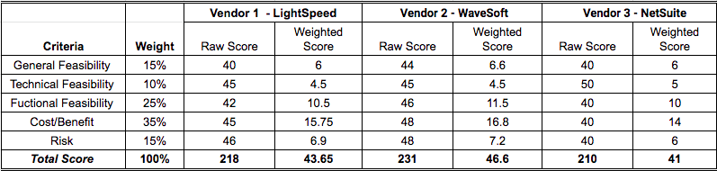Figure 1.4: Assessment Vendor Solutions

**V Implementation Plan**

For this project, we chose to implement our solution for our client using the Waterfall approach. The reason why we chose the Waterfall approach is because it carried many benefits. Some of which include that; developers agree on what will be delivered early in the development lifecycle, making planning and designing more straightforward. Progress is more easily measured, as the full scope of the work is known in advance. Along with Customer presence not being strictly required after the requirements phase. There are six phases in the Waterfall approach; Requirement analysis, System design, Implementation, Deployment, and Maintenance. Our group initially visited our client and had a quick walk through of the restaurant; identify any requirements from the manager and from our own analysis. From there we researched many vendors that would fit our client’s requirements, and narrowed down the list to the best options. We then introduced “WaveSoft” to our client, a vendor that offers services in creating mobile applications for companies, useful software of iKDS and a strong Point of Sales (POS) system. As the project managers, we discussed with our client the benefits of “WaveSoft” and came to an agreement that this would be the best vendor for the restaurant. Executing an efficient requirement analysis early in the development cycle allowed us to continue to progress effectively and ensure our success throughout the rest of the cycle during our project.

**Planning**

*The implementation plan defines how the information technology will be deployed, installed and transitioned into an operational system. The planning phase of the implementation contains a brief outline of the main tasked involved in the implementation. It will provide a description of the individuals who will be in charge of the operation, and the structure of the implementation teams. The plan will discuss the responsibilities of each team, the timeline and cost of the entire implementation. Lastly, it will depict the main objective of this entire project and outcome of the implementation process.*

**1.0 Major Task**

* Hold a staff information meeting
* The staff meeting will be conducted at the beginning of the installation. At this staff meeting everyone will be present and introduced to the technology and software that will be implemented.
* Implementation of the technology and software
* Install the technology devices such as iKDS, WavePOS, WaveTouch and the software into the technology. Configure the device to operate throughout the business on any of the technology devices.
* Testing
* The testing of the software will be conducted in house and will be monitored through the first month of the installation. They will test to find bugs and defeats and find ways to troubleshoot the system defects.

1. **Roles and Responsibilities**

* Client is not involved in this process
* WaveSoft team will be handling the implementation process

|  |  |
| --- | --- |
| **Role** | **Responsibilities** |
| Project Lead | Overseeing project implementation |
| Project Manager | Monitoring and controlling the project evolvement according to timelines and key milestones |
| Client Representative | Ensuring that the project respects and responds to the needs of the company and communicates with the client |
| Database Administrator | Manage physical database resources and configuring and designing backup and restore strategies |
| IT Technician | Providing IT support for the project and coordinating IT development required for the project |

1. **Timeline and Milestone**

* The entire implementation process will take approximately 3 hours.
  + 1-2 hours: WaveSoft technicians will install technology devices and software onto the devices.
  + 1 hour: Training the owner to use the devices and demonstrate how to operate the system for him to train he employees afterwards.

1. **Cost of the entire implementation**

* The cost for the entire installation will cost $10,000 where they will install the software on the devices. Monthly the client will be paying $2000 to WaveSoft.

1. **Objective and Outcomes of the implementation**

With the implementation of the software and technology devices such as the KDS, WavePOS and WaveTouch the communication between the frontline and the kitchen staff will be improved. The KDS installed in the kitchen will help the chefs keep track of their orders and priorities the necessary order depending on their time. Moreover, the servers can update the system, that way they no longer have to go to the back and notify the chiefs. With the new WavePOS system, this will aid in the end-of-day cash procedure. This system will calculate the end-of- day cash and calculate the tips for each server after they have input the necessary information. The WaveTouch installation will aid customers. With this technology installed, customer will be able to place order through self-serve. This will implementation will reduce the waiting period when customer come to place orders for take-out. Overall, with the installation with all these technology devices and the new system software will better aid Cucina Di Paisano as it will help the business process run more effectively and efficiently.

**Installation and Conversion**

The installation process for our vendor, WaveSoft, has played out to become very simple. For the information received there are only a few aspects we as the consulting firm needed to inform our client. To begin with, the parties who are responsible for the installation of the software itself is WaveSoft. The vendor will be sending two software technicians to incorporate the software WavePOS and iKDS. For both services, there is no need for a full system change, however it does require some time to integrate it into the business. For WavePOS, the main function is providing a more technology advanced method for point of sale and have a database will all information gathered automatically. An advantage to this is the focus towards the ability to mimic the existing workflow and interface of the business. This allows training on employees to be much simpler and efficient. As well as for iKDS, all WaveSoft will do is install the software onto the device and provide a quick preview of how the system will operate. Because WaveSoft’s iKDS is mainly just a software to display incoming orders with the table number, time and order details, it only requires a simple integration process. Both WavePOS and iKDS will be installed by WaveSoft employees and will train the owner who will later showcase the process to the business team. All the client needs to do is provide the Windows based PC for the installment location and showcase the TV screen which will already have been fixed into place.

**Testing**

Testing the software will all be done in-house. We aim to carry the testing phase over the course of a month with the help of all the staff members and managers. We have got in contact with WaveSoft, and they told us that they will give a tutorial on how to use the software and how to go about any issues that may arise. They said they will present us with troubleshooting methods and that they are fairly straightforward. We believe that within the first month of use we will be able to get a decent understanding for what the system has to offer and whether it will work for Paisano’s business. When it comes to testing out the system, there are multiple factors to consider. It is important to ensure that all aspects of the system are working and are usable.

We will begin testing by ensuring that all the physical devices are there and in order. Ensure the terminal displays are all working correctly and connected to the network. Next, we will ensure that the display screens are all properly labeled and display the correct items when punched in. The display screen in the back end will be what is used to determine which orders need to be prepared next. Therefore, it is important to ensure that the correct items are displayed in the correct colour labeling. Once we have tested the software using some test transactions, this process will be closely monitored over the course of a month to ensure that there are no issues that commonly arise. In regard to the handheld terminal, we want to ensure that all forms of payments are accepted, including tap, swipe, and the chip reader and sensitive information is encrypted.

Along with testing the individual transactions, we will also be responsible for ensuring that the end of day cash out process is simple and functioning. We will have to run a couple tests along with real end of day cash outs in order to verify that the system is accurate and balancing. This will require the system to be able to distinguish different users via their passcode. Each employee hat works in the front will be given an option to create their own unique passcode which only they are authorized to use. This will be used by them whenever they punch in an order, take payments and finally cash out at the end of the day. This will eliminate any confusion between shift changes and orders that some may not remember entering. Everyone will be responsible for their own inputs. We will monitor the process and verify each day for a month in order to ensure that sales match with the amounts the system outputs in order to ensure that the system is working as it should. If the system passes all the criteria’s, we will then know that we had made the right choice in the POS system.

**Training**

In order for the employees at Cucina di Paisano to be comfortable using WaveSoft there will be two aspects to the training. There will be an online module that all employees including the manager must complete before attending the seminar. The online module will provide the employees information about WaveSoft and a quick overview of the system, its layout and how to perform necessary functions.

There are two main concepts to the WaveSoft software that the employees will be trained on; iKDS and WavePOS. Over the period of a couple hours, there will be an expert for each component of WaveSoft that will be coming on the Weekends before opening to provide the employees training. The training will be focused for the owner and later they owner himself will provide training for all employees. In these seminars, the owner will provide employees a quick overview of what their component entails and help understand how to perform the functions that were in the training module and also complex day to day functions that the employees might find themselves using.

At the training, the employees will be able to role play and go through real life situations in where they will need to perform complex transactions. The seminar will also provide employees the ability to learn to use the new POS system in order to help complete end-of-day cash procedures. The focus of the training will be mainly on iKDS and WavePOS for these are the two components of the three that the employees will be using the most. KDS is also a main component for the manager to completely understand and feel comfortable with for they will be using that aspect of WaveSoft the most. iKDS helps a business perform all its day-to-day functions, provides streamlines the operations and provides real time cloud reporting.

**Documentation**

Every employee at the restaurant must hold two documents that will be provided to them after completing both the training module and the seminar. The employee can choose to either print the document or have it saved on the desktop they completed the module on at the restaurant. The WaveSoft training module will automatically provide the employee a certificate upon completion, but it is the trainers responsibility during the seminar to provide the employee the certificate for the completion of that part of the training.

Another document that will be needed to be developed and provided to all employees is a breakdown of each component of the WaveSoft system and instructions on how to perform certain functions. This document will provide employees a thorough explanation with step-by-step instructions and screen shots of the system in order to help the employees in time of need where a supervisor or manager is not around. The person responsible for creating this document will be the manager. The reason why the owner will be creating this document is because they are required to have the most knowledge about the new system implementation. Therefore, they can assist the employees and be better able to perform daily functions. Given their knowledge of the system after training, they will be required to create a thorough document explaining and showing how to perform certain functions in day-to-day transactions at the restaurant.

The document will be kept as a hardcopy and softcopy on all computers and back-end tablet devices at the restaurant. This will help the employees to have access to the information at all times. The hardcopy will be kept in a binder in the employee room at the restaurant for employees to use to further their knowledge to any new additions to the system and so forth before they start their shift. The softcopy will be available to employees to use as a guide when interacting with the customer to provide them assistance instead of leaving the interaction to receive help from a supervisor or co-worker. Having both a softcopy and a hardcopy of the job-aid will help the employees at the restaurant to provide better service to the clients by being able to provide quicker and better service.

**VI Concluding Remarks**

To conclude our report, we are 85% confident in our decisions throughout this process in selecting a vendor to aid our client. WaveSoft offers us a complete process from the installation to testing to training and to the documentation of the process. In terms of the WaveSoft installation, we believe that this will be a very simple process. We also believe that the system change will also be an easy process and all information will be gathered accordingly in an efficient manner. We believe that the testing process of the software it will also be done smoothly and are confident that we can cover this phase in the one month that we had predicted. WaveSoft has also been very accommodating throughout the process by ensuring that they offer us a tutorial on how to utilize the software and also any troubleshooting that we will need done as we go about the testing. Some flaws that could exist throughout the testing are potential malfunctions of the system that’s being tested or if the system works differently than what we originally wanted. However, we feel strongly that we selected the best system for our client and ensure that the process will run smoothly during the testing stage. In terms of the training, we will offer a complete process online that will test the knowledge of the employees to ensure that they understand the iKDS and WavePOS. We have a WaveSoft representative that will also meet with the owner to run through the modules as this will help streamline the training operation. We are confident that the representative that we have chosen is knowledgeable enough to help with the training and we are also confident that the modules we created offer enough content to learn the system from zero to hero. Finally, we will have provided full documentation of the process for the employees in both hard copy and electronic form.

**References**

NetSuite Software. (n.d.). Retrieved from [https://www.softwareadvice.com/ca/retail/netsuite-retail-management-software-profile**/**](https://www.softwareadvice.com/ca/retail/netsuite-retail-management-software-profile/)

Restaurant Management Apps for iOS. (n.d.). Retrieved from <http://www.wavesoft.com/>

The Best Restaurant Management Software for your business | Lightspeed. (n.d.). Retrieved February 18, 2019, from <https://www.lightspeedhq.com/restaurant/>

Waterfall vs. Agile: Which Methodology is Right for Your Project? (2018, November 20). Retrieved from <https://www.seguetech.com/waterfall-vs-agile-methodology/>

***Appendix A***

*Project charter*

**Project Description**

DAREK Consulting and Technology is working with Cucina di Paisano, an Italian restaurant in order to help improve business processes. DAREK Consulting and Technology will be responsible for a comprehensive examination of the client's business strategy and key goals in the business. DAREK Consulting must also analyze current business processes which the company uses and redesigning any processes that need to be improved. It is crucial to keep business processes aligned with business goals, in order to create highest amount of efficiency possible. All system requirements must be considered when proposing any changes to the business process, as they must be able to implement these new changes within the business, to help with the business strategy and goals. Along with presenting Cucina di Paisano with specific changes and solutions to help improve their business process, they will be presented with the steps they must undertake in order to implement these changes. In order to accomplish this, there will be specific time frames for each phase of the project. It is important to have measurable goals, in order to complete the project in a timely manner with no delays and complete project goals and objectives.

**Project Justification**

Cucina di Paisano is seeking to improve their technology sector of the company through three different aspects. One, the restaurant is seeking to implement a system that will assist in quicker and easier communication amongst the waiters and cooking team at the back of the restaurant. Having a high traffic of customers during peak times such as lunch and dinner, the restaurant wants to work towards quicker communication of orders amongst the employees to therefore help more customers as soon as possible. Second, the company is seeking to increase revenue from orders made online on the company’s website and through third party websites such as UberEats and SkipTheDishes. In order to do so the company is seeking to advertise its brand through various social networks; Instagram, Twitter, and Facebook indicating that customers can order and receive their food all without leaving the comforts of their home. Lastly, the company wants to be able to have access to a digital daily cash revenue that is made from each waiter/waitress. Instead of having each waiter/waitress calculate by hand End of Day total sales, the company would like to have an automatic method for each waiter/waitress to easier manage the amount each of them have made daily.

**Business Case**

Our group will be looking into implementing a computerized system that could help the different ends of the restaurant communicate on a level that is technologically advanced and efficient. This is an important need for something like a restaurant because of the two main different areas that they employ, such as the back end and the front end. In something fast pace like the restaurant industry, the business value generated from this would be that the restaurant would now be operating in an efficient manner and in a way where somebody such as the waiter could virtually communicate with the chef or manager with the touch of a button with issues such as food orders and table requests. This will also improve customer satisfaction and requires less process time as a whole as the customers in the restaurant business are all about efficiency and quickness when they go out to enjoy a meal and the needs of the customer will be satisfied if the front and back end technology is improved. As well, the market demand is all in the online food ordering platform and we want to bring value to the business by focusing heavily on pushing online orders and putting a large amount of focus on the online aspect of this business.

**Business Objectives**

The main objective of the project is to analyze and improve any current business processes and provide the steps and tools that may be required to implement these changes. DAREK Consulting’s main goal is to improve Cucina di Paisano’s technology side to their business which is planned to improve three different aspects of the business. First DAREK Consulting will be looking into implementing a system to help the front and back end of the restaurant to communicate to one another on tables being helped and soon to be helped. This will help improve time efficiency by cutting some buffer time from the moment a table places and order, to the time their food is received. Second, DAREK will be trying to implement a more social and online friendly user face. This is in hopes to increase online food orders through their website and other external third-party delivery services such as UberEats, SkipTheDishes, etc. The goal of this is to be more accessible by more people, giving customers more methods to receive the food they love, regardless of where they may be. Finally, DAREK would like to implement a computerize daily cash out system for each waiter/waitress to use. This will make daily cash out system keep track of total bill amounts, along with total tips in a clear simple format that does not require any work from the employee. The goal of this is to use staff time more efficiently, as cash outs is a task that is undertaken multiple times throughout the day depending on the number of staff members on the floor. Once these changes have been implemented, it is believed that it will help Cucina di Paisano continue to run their business effectively and more efficiently while still having their business goals and strategy in place.

**Requirements**

The purpose of this project is to help Cucina di Paisano improve their technology in order to advance their business and excel in their sales. To accomplish this, DAREK Consulting must ensure to meet these requirements and use it as a guideline to achieve their end goal. The following are:

1. Less wait time for food at each table (timer affect) to increase Communication between front and back of the restaurant.
2. Organization of online food orders between incoming orders and kitchen.
3. Computerize daily cash out of each waitress

**Constraints**

|  |  |
| --- | --- |
| ***Constraint 1*** | Budgeting |
| ***Implications*** | * Not allocating cost for each specific unit to accomplish task can result to insufficient funds * By utilizing the budget, it will help the company allocate cost throughout the project lifecycle. |

|  |  |
| --- | --- |
| ***Constraint 2*** | System Failure |
| ***Implications*** | * When software systems that the company utilize fails it can lead to a delay in the business process * Loss of information/data and day to day transaction * Must deploy a backup plan to ensure that the business can operate its day to day activities without systems |

|  |  |
| --- | --- |
| ***Constraint 3*** | Available Resources |
| ***Implications*** | * Limited staffing and resources can limit the company from being productive * It is essential to allocate cost based on the necessity of the company * Not exploiting the available resources can impact that company as task requirements may not be accomplished or completed to its fullest |

|  |  |
| --- | --- |
| ***Constraint 4*** | Table management |
| ***Implications*** | * Restaurant table management is a key element of time which impact the profitability and customer experience of the restaurant * Inefficient utilization of table results in losing potential customers, however overbooking can also be a disadvantage as customers are delayed which can result to them not returning |

|  |  |
| --- | --- |
| ***Constraint 5*** | Time |
| ***Implications*** | * Not meeting customers’ orders and seating customer in a timely manner can impact the restaurant as they might lose customers * Not completing/ serving food in a short period of time will slow the business process down |

**Acceptance Criteria**

The company expects to have its technology sector improved by the end of the first quarter of 2019 (March). The company is seeking to move quickly into being able to communicate efficiently amongst employees. The reason being is because the Christmas holiday season is around the corner, and are known to having a higher traffic of customers during those times. Being able to have the new system implemented for quicker and more efficient communication between front and backs staff will help during busy periods. The company wants to implement the new communication system by the month of November.

Advertising the new brand through various social media platforms is something that the company wants to start implementing into their practice following the New Year. In 2019, the company is looking to increase online sales by 10% through advertising that customers can order online through the company’s website and using third party websites. The company is looking to expand their brand within social media platforms by January 2019.

Lastly, the company expects to have a system that will indicate the End of Day cash totals for each waiter/waitress by March, 2019 which will be the end of the first quarter. The company is seeking to have met all the criteria by the end of the first quarter in order for them to look forward into a more successful year.

**Assumptions**

It is crucial to make a few assumptions during the planning of the project as it will help generate the flow of our project. Throughout the lifecycle of the project we will encounter many various issues and it helpful to state some assumption that we will be aware within the project.

Assumption we will abide are:

* Equipment will be available to all staff when required
* All stakeholders of the company will be present at each meeting at all times. However, encase they are not able to attend the meeting, it will be assumed that they will be present at the next meeting
* Resources will be accessible to all staff at all times
* Staff members are assumed to dress in uniform for each shift they attend
* If there is a change in the environment, preventing staff to arrive at work they will be a schedule prepared to ensure that the team has not fallen behind their work

**Milestone Schedule**

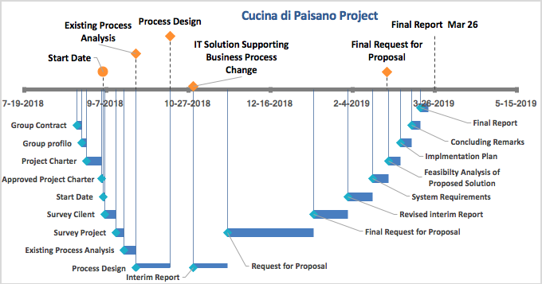

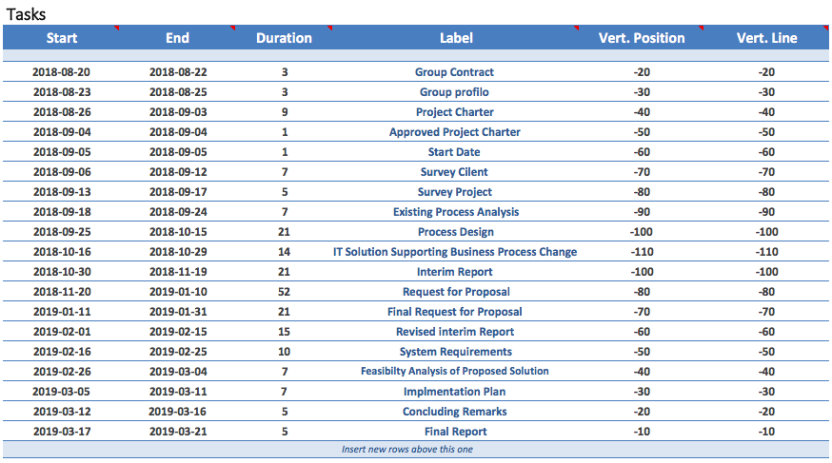

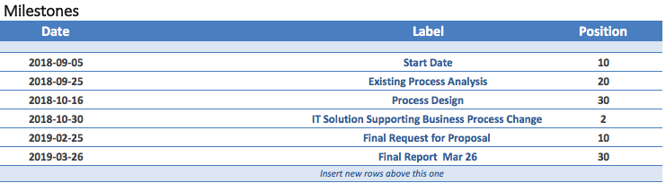

**Project Manager**

The project manager of this company is Ragavi Ravindran. As project manager, she has a set of important responsibilities to fulfill and below clearly states the what they are.

Time management:

With any project, time management is a crucial component and is what decides whether the project is successful or if it fail. When a deadline is given to a team, it must be meet, however when a project works past it and requires additional time to be completed, it results in a lower value due to the disturbance it caused. As project manager, it is very important to create a set schedule, define deadline dates and ensure these dates are realistic to meet.

Budget Estimation:

At the beginning of any project, deciding on the budget will determine the method of the project. The project manager must figure out the require funding need for the project and obtain approval. Once completed, the real task begins in trying to complete the project but also remain within the provided budget.

Monitoring Project Process:

As a project manager monitoring your project is necessary in order to keep track of its progress. The project manager must collect all data, status reports of their team, ensure the project is on schedule and provide the required reports after. As the project continues, there will be changes and alteration needing to be done and the project manager must monitor all these items for the overall report at the end of the project.

Team Motivation and Organization:

Over all other responsibilities, project manager must ensure that his/her team are well organized and motivated to work for them. If the manager were too pile work on top of them and make their team work day and night with no appreciation or break, the team will be being to resist the job and the project will either fail or do horribly. Instead, if the project manager keeps the team motivated and engaged with the project, it will get a better work environment and help to project excel.

**Conflict Resolution**

In case of conflict occurring in the process of implementing these systems, our group will have to come up with a solution to the issues as quickly as possible. Most of the time, a conflict that a project manager does not really handle would include things such as technological issues or worker conflict. If technological conflict occurs during the project, it will have to be fixed as quickly as possible to sort out any further issues. If conflict between workers occurs during the project, it will be our responsibility to sort out this conflict in a mature and efficient manner. We only have so little time in the implementation of this project that we will have to do our best to avoid any conflicts if possible and if any do arise, it is our duty to sort through them as quickly as we can.

**Project Sponsor Approval**

Prepared: DAREK T&C Reviewed by: Ravindran Kanagasabai Approved by: Ravindran Kanagasabai

Date: 26/08/2018 Date: 27/08/2018 Date: 18/11/2018

***Appendix B***

Request for Information

Request for Information (RFI) for: Cucina di Paisano

Issue Date: January 28th , 2019

1. **Disclaimer**

This Request for Information does not create any representation nor implies, that:

* any procurement process will proceed; or
* if a procurement process does proceed, the participant’s tender will be given special consideration.

Participants are still required to follow any tender or procurement process that may take place.

This Request for Information does not indicate a commitment to any particular course of action.

1. **Introduction**
2. **Background**
   1. DAREK Consulting and Technology consist of five individuals, currently in fourth year at Ryerson University, pursing a major in Business Technology Management. As student this is a great opportunity for us to apply our knowledge, skills and experiences to provide a company with detail analysis and advise about their current business. Cucina di Paisano is an Italian restaurant located at York Mills and Don Mills. The restaurant has been open for over 50 years and is continuing to expand their business with their loyal customers and newcomers. As a team, DAREK Consulting and Technology will be assisting Cucina Di Paisano in the advancement of technology that can be utilize throughout their operation.
3. **Purpose**
   1. DAREK Consulting and Technology will be responsible for a comprehensive examination of the client’s business strategy and key goals in the business. DAREK Technology and Consulting is seeking to implement a system that will assist in quicker and easier communication amongst the waiters and cooking team at the back of the restaurant as well as the company wants to be able to have access to a digital daily cash revenue that is made from each waiter/waitress. This Request for Information is an information gathering process in which DAREK Technology and Consulting is seeking to collect information and opinions from possible vendors. This Request for Information and the responses provided may be used a precursor to a procurement process.
4. **Confidential**
   1. DAREK Technology and Consulting will treat all responses confidentially.
5. **Contact Person**

The Contact Person for this Request for Information is:

Company: DAREK Technology and Consulting

Name: Ragavi Ravindran

Title: Project Manager

Address: 72 Gillingham Ave

Markham, ON

L3S 3Y3

Telephone: 647 824 7284

Email: [ragavi.ravindran@ryerson.ca](mailto:ragavi.ravindran@ryerson.ca)

1. **Address**

Please return completed responses by February 28th 2019 at the latest.

Earlier responses are welcomed.

Please submit responses to:

ragavi.ravindran@ryerson.ca

It is important for potential vendors to have the following displayed on their response in order to create the search process effective. The following requirements are:

1. RFI appears in the subject line of the email.
2. Your submission is zipped and virus checked prior to submission.
3. **Scope**

In a collaboration between DAREK Technology and Consulting and Cucina di Paisano, we have a key scope for this project. We are trying to simplify and shorten the order process for the front-line and back-line. We will try to introduce an electronic device to offer a signal when orders are placed, and of the arrival of their customer’s meal. In order to do so, we are seeking a display screen that has everything the kitchen staff needs in order to prepare the meals on time, done all strictly electronically. This screen must be able to display the time order placed, and how long the customer is waiting. We are also attempting to automate the process of calculating the front-line staff tips and also the food order totals. Cucina di Paisano is requesting to have a program which helps calculate all totals automatically in order to avoid errors.

1. **System requirements** 
   1. Functional Requirement

At the high level, we want a system that is easy to use and allows for free communication for all departments operating in the restaurant. The first system must meet the specific target of simplifying the daily operations of the front-line workers, kitchen staff and customers through processes such as television monitor communication with current and future orders and also table availability. The other system must meet the specific target of simplifying the tip and cash totals calculated at the end of the day and having them all done strictly electronically. The functional requirements for the implementation of these systems include communication, system creation, order creation and processing and transactional data.

Communication: The first system would have the functionality of efficient communication between all different departments operating within the restaurant, eliminating the old and outdated current operation. It would facilitate communication between the front-line staff such as waiters and the kitchen staff, where the kitchen staff will have all current and future orders that need to be fulfilled displayed digitally through a monitor. It would facilitate communication between the front-line staff and the customers by an electronic device displaying the current wait time for a table and what table numbers would need to be cleaned and serviced before the next set of customers sit down. The system will allow for the front-line staff to confirm when a table is vacated and when a table is taken over and they would consistently update the system to improve the communication with the customers.

System and Order Creation: The electronic system would have the functionality of having the front-line staff consistently update the kitchen staff with what needs to be cooked with all specific attributes for a certain order. The electronic system will also allow the kitchen staff to update with what food needs to be ordered to prepare meals for that business day and what ingredients need to be restocked.

Transactional Data: All payments throughout the day for the meal and also the server tips would be generated through an end of day electronic report that has all the dollar totals for each specific server and how much they generated in tips.

* 1. Non-Functional Requirement

When looking at non-functional requirements, we must consider any restrictions or limitation that should be looked at when designing the system. Ensuring that the system operates effectively and efficiently is one of the main concerns with the new system we are implementing. Priority would be one of the main issues that the system is required to operate and the system must detect which order has been delayed. The non- functional requirements we will be considering is hardware, capacity, operating system and usability.

Hardware: The hardware that will be required for our implementations is a POS system where all transactions will be processed and that links with a monitor in the kitchen. This monitor will be responsible for displaying all incoming orders in the order of priority. This will allow the kitchen staff to know what needs to be done and when.

Capacity: The capacity of the system should have the ability to display all orders placed throughout the restaurant. This includes anything from dine-in orders, takeout orders and online orders. This would allow for the staff to know whether to prepare the meal for a take-out or dine-in. The system should also have the capability to store high volumes of orders as often times there are large group bookings that take place. The storage capabilities should allow for users to go back and look at a history/log of orders for any verification purposes.

Operating System: The operating system should have the ability to update via Wi-Fi. This means that if there are any future updates to the system that need to be made, it can be done so through the internet. For example, if there are any issues that arise with the system, having the ability to update a patch will better the system. Moreover, the operating system utilized throughout the restaurant should have the ability to allow user to run other applications as well such as balancing cash at the end of the day, a clock in software that allows employees to punch in for their shift.

Usability: The system is going to be used by most of the staff members. Therefore, the system should have the capabilities of representing what the orders are, and the method they were ordered from. The information represented should be simple to read and display all the necessary information regarding to the order. To understand how the system operates, the company will conduct proper training for all staff members.

1. **Requirement Chart**

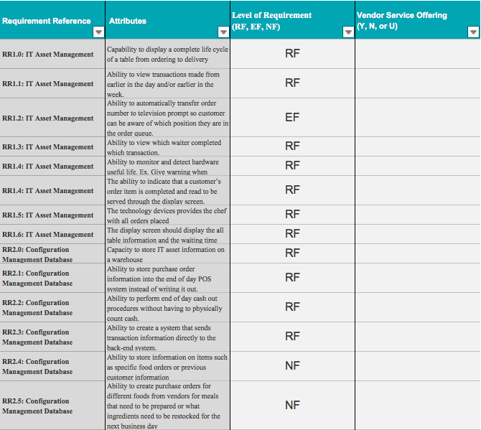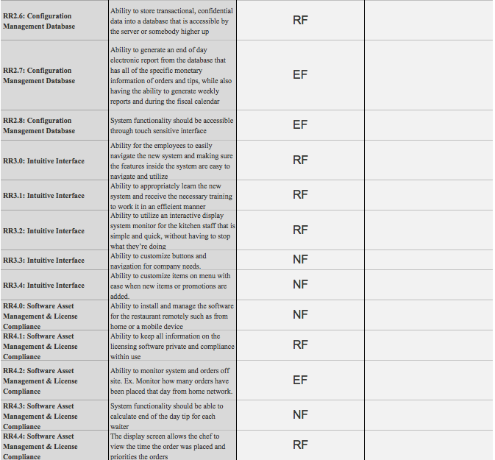

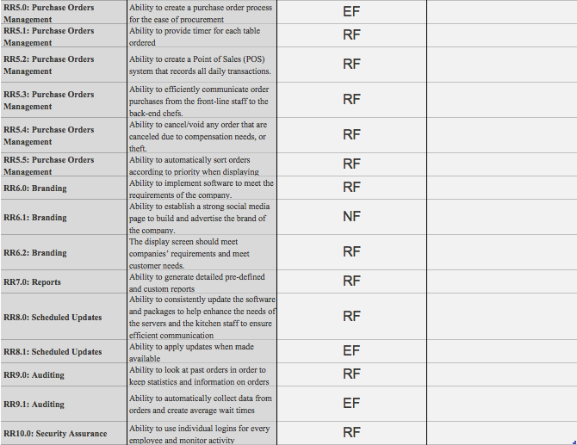

1. **Response Schedule**

|  |  |  |
| --- | --- | --- |
| Milestone | Description | Due Date |
| Issue of RFI | DAREK Technology and Consulting formulate and issue the RFI document to selected vendors | January 28nd, 2019 |
| Vendor Response | Potential vendor proposes requests information based on requirements provided by DAREK Technology and Consulting | February 28st, 2019 |
| Potential Client follow up with Vendor | DAREK Technology and Consulting will evaluate all proposals | March 26th , 2019 to April 26th 2019 |